6.1

a).

b).

ANOVA for Selected Factorial Model

Analysis of variance table [Partial sum of squares]

Sum of Mean F

Source Squares DF Square Value Prob > F

Model 1612.67 7 230.38 7.64 0.0004 significant

A 0.67 1 0.67 0.022 0.8837

B 770.67 1 770.67 25.55 0.0001

C 280.17 1 280.17 9.29 0.0077

AB 16.67 1 16.67 0.55 0.4681

AC 468.17 1 468.17 15.52 0.0012

BC 48.17 1 48.17 1.60 0.2245

ABC 28.17 1 28.17 0.93 0.3483

Pure Error 482.67 16 30.17

Cor Total 2095.33 23

The Model F-value of 7.64 implies the model is significant. There is only a 0.04% chance that a "Model F-Value" this large could occur due to noise.

Response: Life in hours

ANOVA for Selected Factorial Model

Analysis of variance table [Partial sum of squares]

Sum of Mean F

Source Squares DF Square Value Prob > F

Model 1519.67 4 379.92 12.54 < 0.0001 significant

A 0.67 1 0.67 0.022 0.8836

B 770.67 1 770.67 25.44 < 0.0001

C 280.17 1 280.17 9.25 0.0067

AC 468.17 1 468.17 15.45 0.0009

Residual 575.67 19 30.30

Lack of Fit 93.00 3 31.00 1.03 0.4067 not significant

Pure Error 482.67 16 30.17

Cor Total 2095.33 23

The Model F-value of 12.54 implies the model is significant.

There is only a 0.01% chance that a "Model F-Value" this large could occur due to noise.

Effect B,C and AC are significant

c). $y_{ijk}=40.8333+0.1667x_{A}+5.6667x_{B}+3.4167x_{c}+4.4167x_{A}x_{C}$

Coefficient Standard 95% CI 95% CI

Factor Estimate DF Error Low High VIF

Intercept 40.83 1 1.12 38.48 43.19 1.00

A-Cutting Speed 0.17 1 1.12 -2.19 2.52 1.00

B-Tool Geometry5.67 1 1.12 3.31 8.02 1.00

C-Cutting Angle 3.42 1 1.12 1.06 5.77 1.00

AC -4.42 1 1.12 -6.77 -2.06 1.00

Final Equation in Terms of Coded Factors:

Life =

+40.83

+0.17 \* A

+5.67 \* B

+3.42 \* C

-4.42 \* A \* C

Final Equation in Terms of Actual Factors:

Life =

+40.83333

+0.16667 \* Cutting Speed

+5.66667 \* Tool Geometry

+3.41667 \* Cutting Angle

-4.41667 \* Cutting Speed \* Cutting Angle

d). 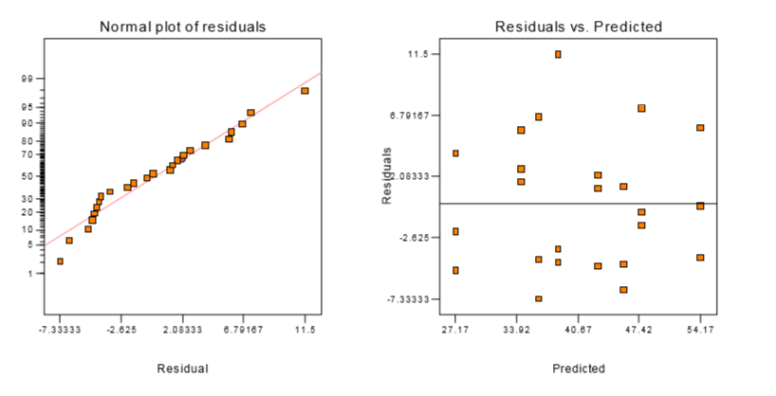

e).

6.5

a).

Response: Vibration

ANOVA for Selected Factorial Model

Analysis of variance table [Partial sum of squares]

Sum of Mean F

Source Squares DF Square Value Prob > F

Model 1638.11 3 546.04 91.36 < 0.0001 significant

A 1107.23 1 1107.23 185.25 < 0.0001

B 227.26 1 227.26 38.02 < 0.0001

AB 303.63 1 303.63 50.80 < 0.0001

Residual 71.72 12 5.98

Lack of Fit 0.000 0

Pure Error 71.72 12 5.98

Cor Total 1709.83 15

The Model F-value of 91.36 implies the model is significant. There is only a 0.01% chance that a "Model F-Value" this large could occur due to noise

b). 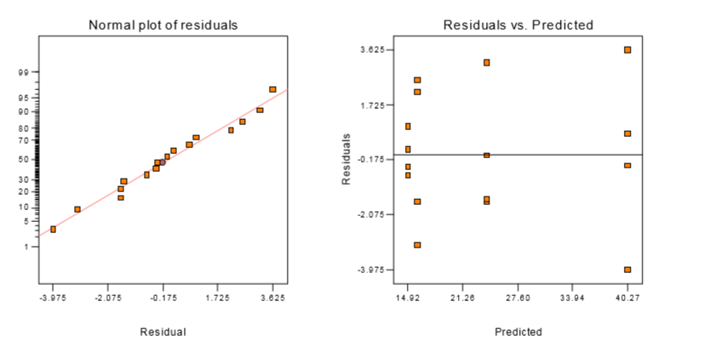

c).